Butterfly pattern calculation

Where: D = diameter of guide bushing
d = diameter of cutter
Df = allowance beyond outside dimensions of insert (“f” for final)
A = final opening dimension (both vertical and horizontal)
a = actual insert dimension
D – d = Df
Df + a = A
Method:
- Use a vernier or digital caliper for all measurements.
- Measure the width of the “waist” and overall length of the insert (0.000”).
- Use the calculations above to obtain the opening measurements of the “waist” and “vertical” height of the pattern opening.
- Make the centre, angled portion by gluing two pieces that are exactly half of “A” (vertical) and glue them together in pairs. Take great care in keeping the points of the angled ends exactly even.
- Assemble to center section on a gluing surface with the points that form the “waist” separated with a waste piece that is cut exactly the dimension of “A” (waist). Add two larger pieces top and bottom to complete the pattern. Clamp and glue tope, centre and bottom sections together. Trim the outer perimeter of the pattern to suite.
- If you are to err in execution of the halves of the centre section, make it on the small side. It’s a simple matter to carefully file the top and bottom portion of the opening after assembly to achieve the exact size. Similarly, err on the short side when cutting the “waist” spacer block. Making the whole opening wider can then be accomplished by carefully filing the top and bottom halves on one side.
- Remember, we’re talking in the thousandths of an inch order of magnitude. It’s not as hard as it sounds.
Clamping mechanism for patterns.
- Note the wedges at the bottom for applying clamping pressure.
- “A” represents the dimensions derived from the previous calculations.
- Centre sections were glued together previously.
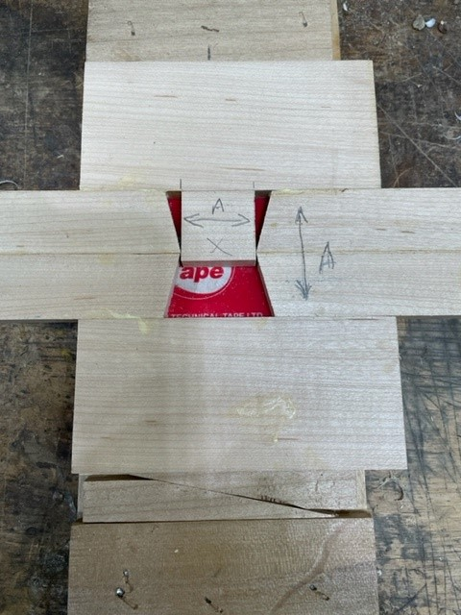
- Waste will be trimmed off to make a clean rectangle.

